

Session: 2023-2024

**MINI PROJECT REPORT**

**On**

**“Restaurant management system ”**

**BACHELOR OF TECHNOLOGY IN COMPUTER**

**SCIENCE AND ENGINEERING**

**(DATA SCIENCE)**

**Submitted to-**

**Mr. Mudassir Sir**

**(Department of Computer Science & Engineering)**

**Submitted by-**

**Name:- Harsh Verma Name:- Shobit Choudhary**

**Roll No. – 2100681540021 Roll No. - 2100681540043**

**Name:- Harsh Tyagi**

**Roll No. – 2100681540020**

**5th SEMESTER**

**DEPARTMENT OF COMPUTER**

**SCIENCE AND ENGINEERING(DS)**

Table of contents

Description Page No.

Declaration I

Certificate II

Acknowledgement III

Introduction 1

Abstract 2

Graphical Abstract 3

Design Flow/Process 6-9

Description of HTML and CSS 10-14

Chapter 5-Output Screens and Code 15-23

References

**MEERUT INSTITUTE OF ENGINEERING AND TECHNOLOGY, MEERUT**

**DECLARATION**

We hereby declare that the project entitled -“ Website for restaurant”, which is being submitted as Mini Project in department of Computer Science and engineering to Meerut Institute of Engineering and Technology, Meerut (U.P.) is an authentic record of our genuine work done under the guidance of

Prof. “Mr. Mudassir Sir” of Computer Science and Engineering (Data Science, Meerut Institute of Engineering and Technology, Meerut.

Date: 15/12/2023

Name of student: Harsh Verma

2100681540021

Shobit Choudhary

2100681540043

Harsh Tyagi

2100681540020

Place: Meerut

**CERTIFICATE**

This is to certify that mini project report entitled – “ Website for Restaurant management system ” submitted by “ Harsh Verma (2100681540021) , Shobit Choudhary (2100681540043), Harsh Tyagi(2100681540020)” has been carried out under the guidance of

Prof.- “Mr. Mudassir Sir” of Computer Science and Engineering(Data Science), Meerut Institute of Engineering and Technology, Meerut. This project report is approved for Mini Project in 5th semester in “**Computer Science & Engineering**” from Meerut Institute of Engineering and Technology, Meerut.

**Internal Examiner :- Mr. Mudassir sir**

**Date: 15/12/2023**

.

**ACKNOWLEDGEMENT**

I express my sincere indebtedness towards our guide Prof., “Mr. Mudassir Sir” of Computer Science and Engineering, Meerut Institute of Engineering and Technology, Meerut for his valuable suggestion, guidance and supervision throughout the work. Without his king patronage and guidance the project would not have taken shape. I would also like to express my gratitude and sincere regards for his kind approval of the project. Time to time counseling and advises.

I owe sincere thanks to all the faculty members in the department of Computer Science and engineering for their kind guidance and encouragement time to time.  
  
**Date : 15/12/2023**

**Student’s Name:** Harsh Verma

2100681540021

Shobit Choudhary

2100681540043

Harsh Tyagi

2100681540020

**INTRODUCTION**

We are preparing a website in which we are providing the online booking of food service which reduce the extra commision of the apps like Zomato , Swiggy , we are using HTML , CSS for the designing of the website .

"What other people think” has always been an important piece of information for most of us during the decision-making process. The Internet and the Web have now (among other things) made it possible to find out about the opinions and experiences of those in the vast pool of people that are neither our personal acquaintances nor well-known professional critics — that is, people we have never heard of. And conversely, more and more people are making their opinions available to strangers via the Internet. The interest that individual users show in online opinions about products and services, and the potential influence such opinions wield, is something that is driving force for this area of interest. And there are many challenges involved in this process which needs to be walked all over in order to attain proper outcomes out of

them. In this survey we analysed basic methodology that usually happens in this process and measures that are to be taken to overcome the challenges being faced.

**ABSTRACT**

We aim to design and create a e commerce website using HTML CSS . Our project is of frontend- based so, we have completed that part. Whenever user open the website then they got basic to advance level of information about C language. Lots of resources are also available in that particular website and on the other hand quizes part are available in which user clear its doubt by practicing questions. After go through with this website all its prerequisites should be clear like having proper knowledge of syntax, data types and so on. In our project users can solve the puzzle which will help in clearing their doubts about the programming language. They will be confined to a timer, within which they have to solve the given problem, if they fail to

do so in the given time limit, then the problem will automatically end. This feature of time restriction will help the user in developing the quality of efficient thinking in a limited time. Lack of resources is still a major problem for learners as very limited resources contain proper and full content. So, A learner need not to switch from one site to other. They can easily find questions related to each topics and they can follow the proper roadmap in order to accomplish the goal. They can test themselves with the quizzes in order to have a proper revision. They will be provided with a stupendous GUI (Graphical User Interface) which would help them in

interacting with the application with ease. To accomplish the coding part, we have chosen VS Code IDE and Google Chrome Browser to test the website in real time by hosting it on the live server, it is very simple to use and the Interpretation of any program is quite easy not only this it also provides beginners a friendly environment.

**GRAPHICAL ABSTRACT:-**

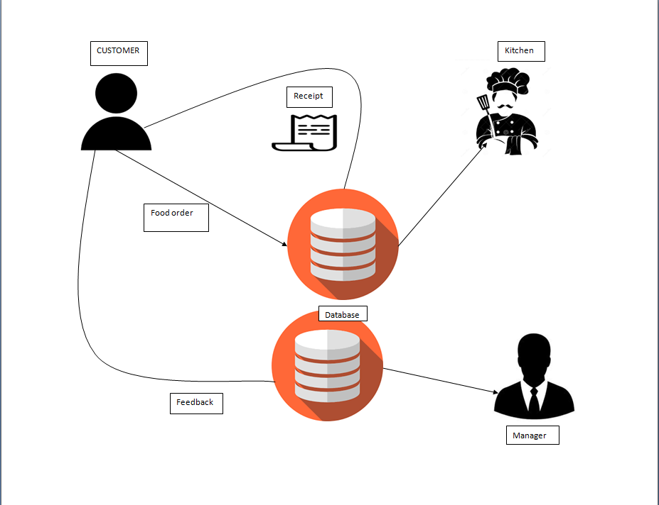

**Design flow/Process:­-**

**Constraints Identification:-**

### Marketing strategy

### Social proof

### Customer support and contacts

### Proper product showcase and descriptions

### Shipping rates

### Payment options

### Registration and related issues

### Website search and filtering functionality

### Optimization before and during website development

* **Time** :- During the arranging period of the advancement lifecycle, we zeroed in on how long we would expect for project completion. This guaranteed that we worked inside the time constraints.
* **Cost** :- While sorting out the funds expected to effectively complete the venture, we put forth a most extreme line we can spend for the undertaking and guaranteed that regardless of whether additional assets are required, the cost constraints won't be impacted.
* **Scope** :- As currently referenced in the venture plan, our undertaking is fairly interesting and many haven't planned anything like this. Therefore, the scope constraints preclude from the conversation as we did a very great job by the decision of the venture
* **Quality** :- Our group has made an honest effort to hold the nature of the venture within proper limits. Rest, the client input will permit us to make alterations as required monitoring the quality constraints
* **Benefits :-** Being one of a kind in its own particular manner, it has a ton of advantages. The advantages of the application don't appear to stop just like a stage which is connected with endlessly learning is a continuous cycle in any individual's life
* **Risk** :- As currently talked about, the improvement of an undertaking offers a great deal of dangers that might be of some value, however holding them within proper limits is what we truly need to focus on the improvement

Level 0 DFD

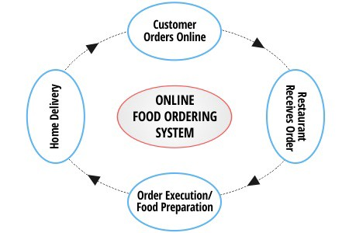

Level 1 DFD



Level 2 DFD

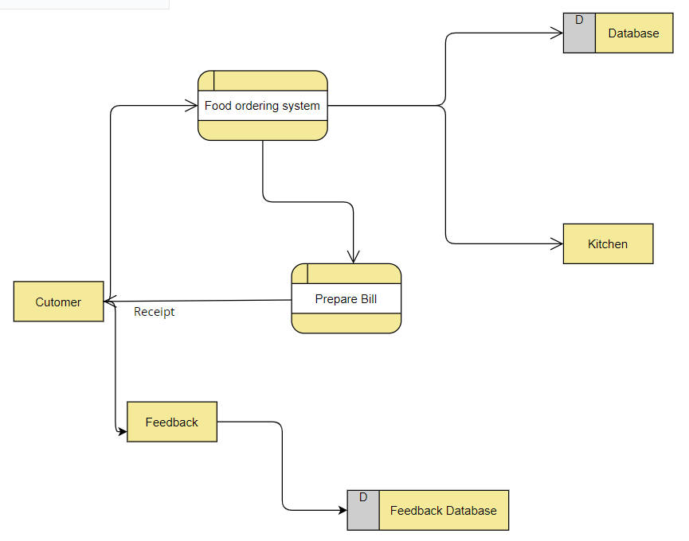

**Description of HTML**

The **HyperText Markup Language** or **HTML** is the standard markup language for documents designed to be displayed in a web browser. It can be assisted by technologies such as Cascading Style Sheets (CSS) and scripting languages such as JavaScript.

Web browsers receive HTML documents from a web server or from local storage and render the documents into multimedia web pages. HTML describes the structure of a web page semantically and originally included cues for the appearance of the document.



**Description of CSS**

**Cascading Style Sheets** (**CSS**) is a style sheet language used for describing the presentation of a document written in a markup language such as HTML or XML (including XML dialects such as SVG, MathML or XHTML).CSS is a cornerstone technology of the World Wide Web, alongside HTML and JavaScript.

CSS is designed to enable the separation of presentation and content, including layout, colors, and fonts.This separation can improve content accessibility; provide more flexibility and control in the specification of presentation characteristics; enable multiple web pages to share formatting by specifying the relevant CSS in a separate .css file, which reduces complexity and repetition in the structural content; and enable the .css file to be cached to improve the page load speed between the pages that share the file and its formatting.



**Output screen :-**

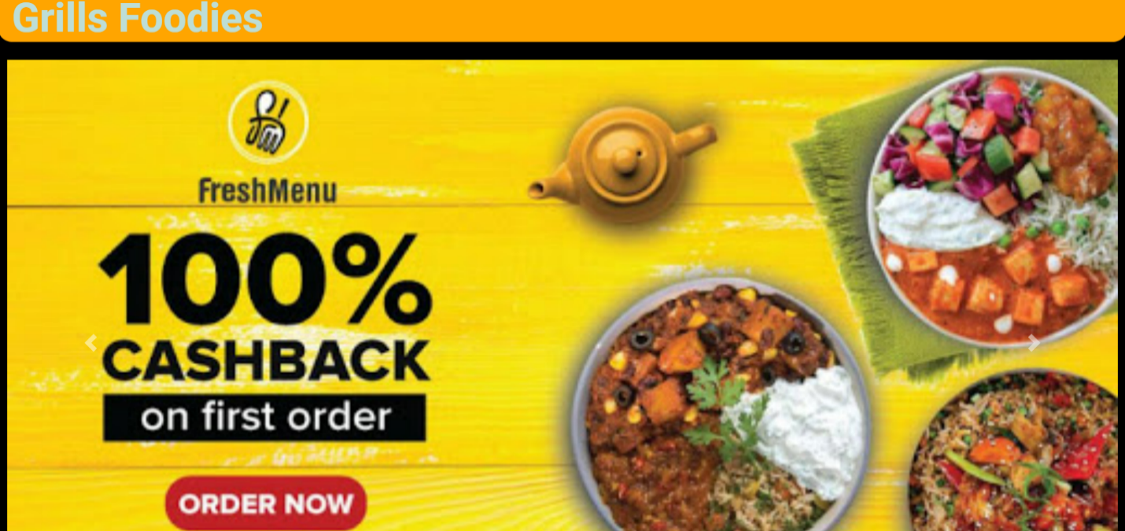

When we enter data in this form the data entered will saved in the database shown below in table named as orders and then from there restaurant managemet will notified about the new entry after which food will be delivered to the respective customer .

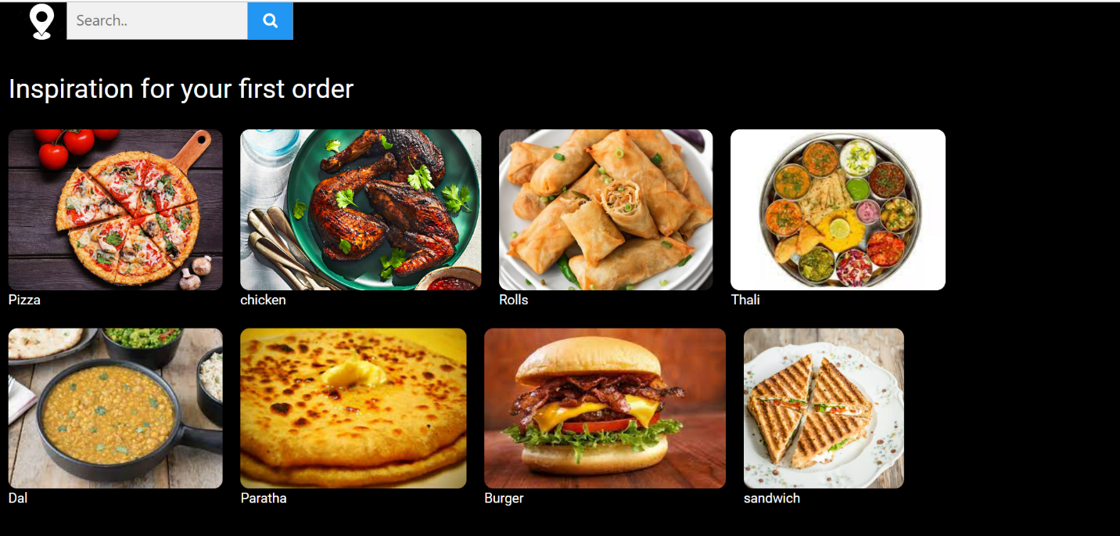

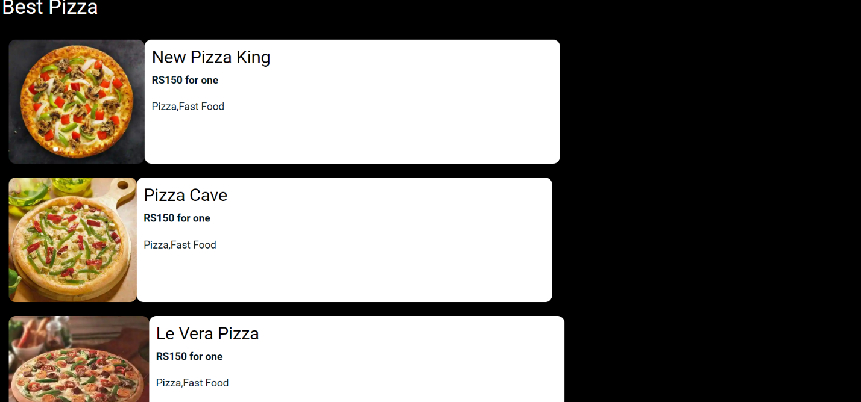

When we enter data in this form the data entered will saved in the database shown below in table named as feedbacks and then from there restaurant managemet will notified about the new entry after which management will try to improve according to feedback given by customer .

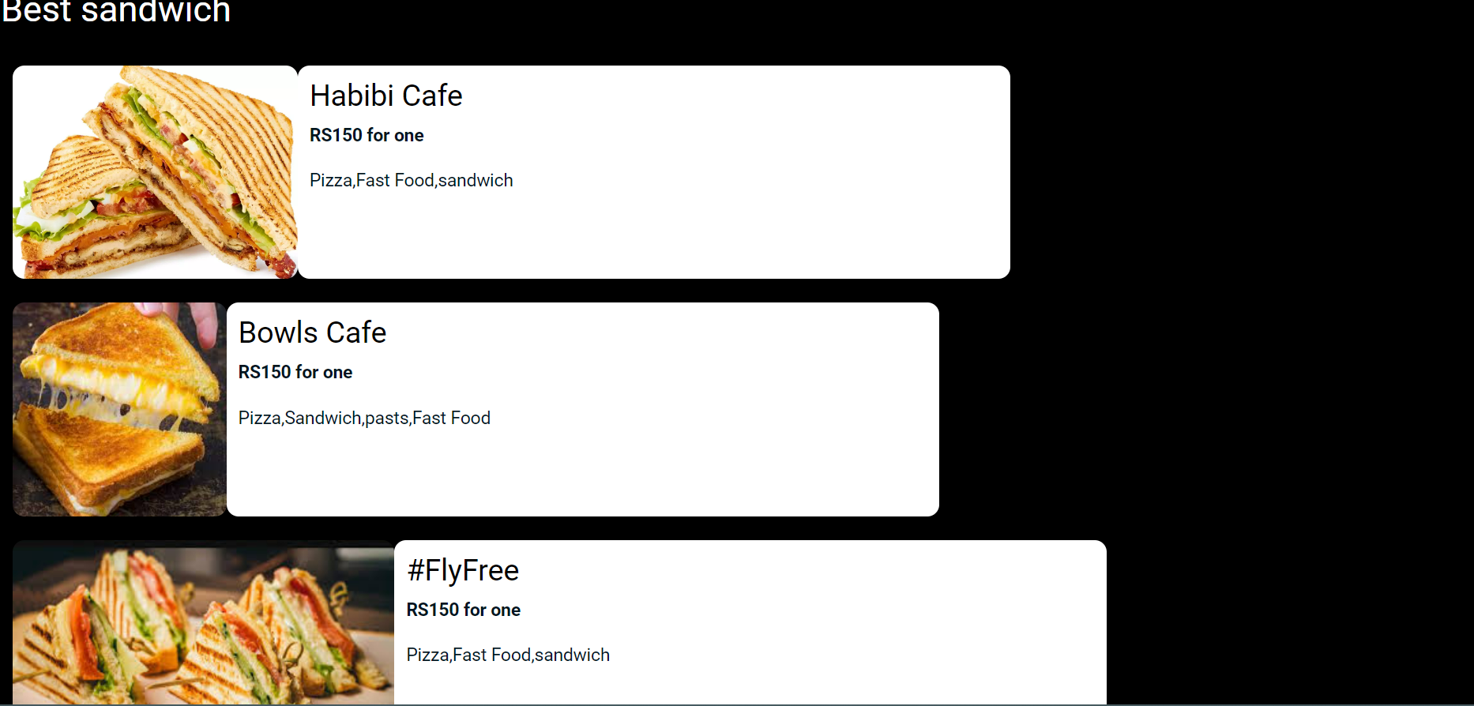

These are pages to check rate list of the food items and using home bottom we can switch back to home page from where we can book food .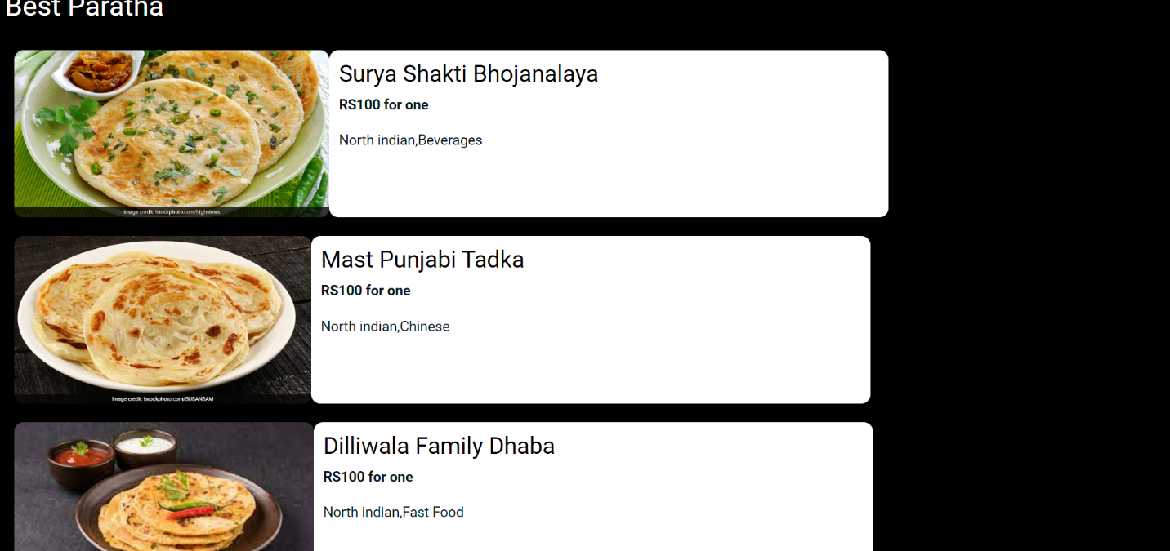

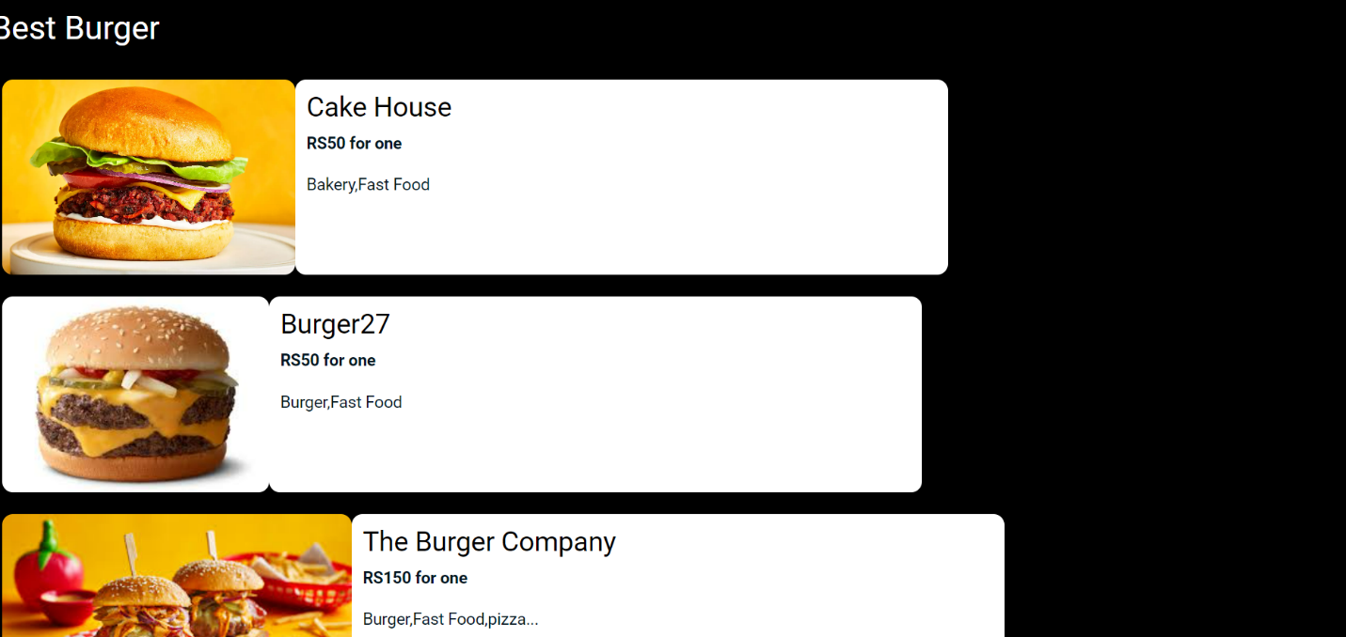

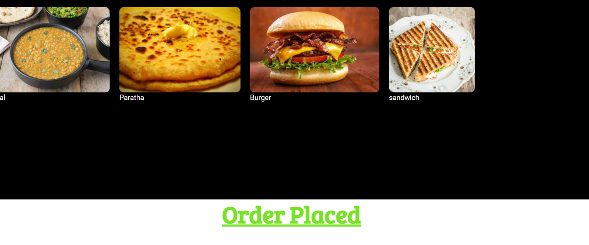

**Source code :- for creting hyper link**

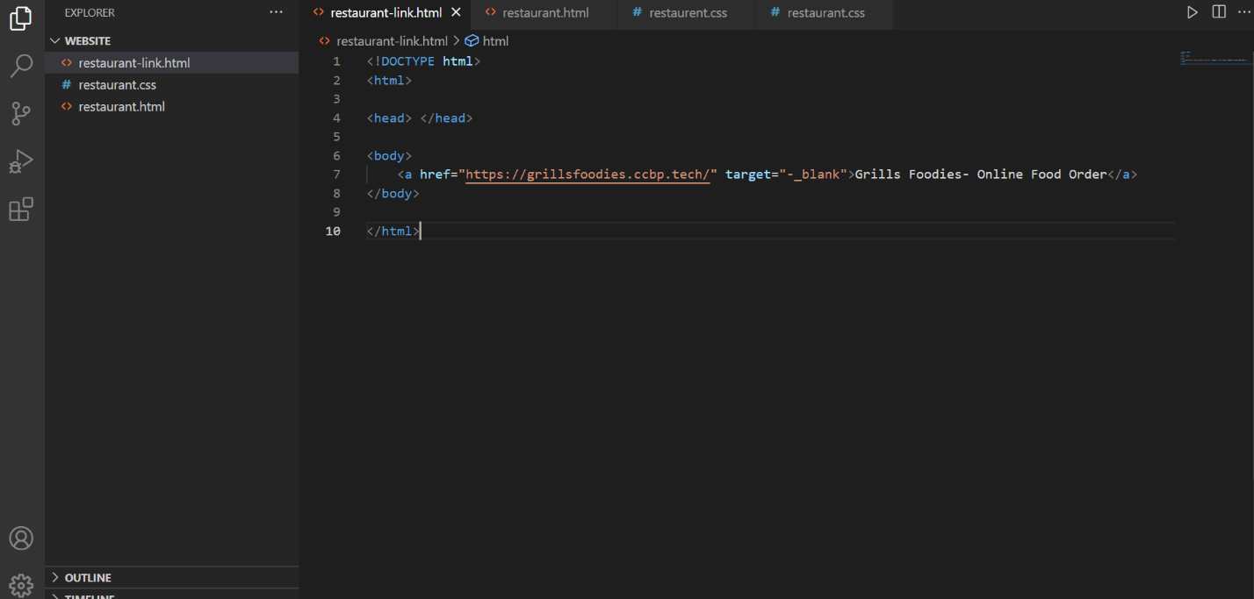

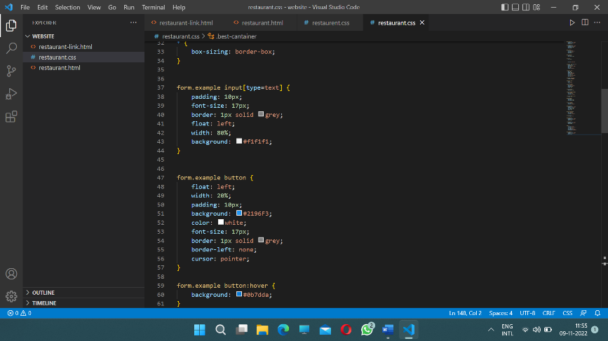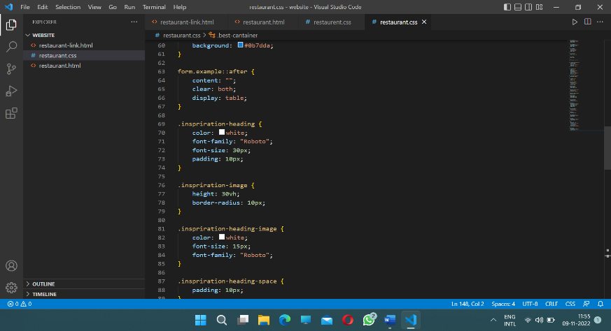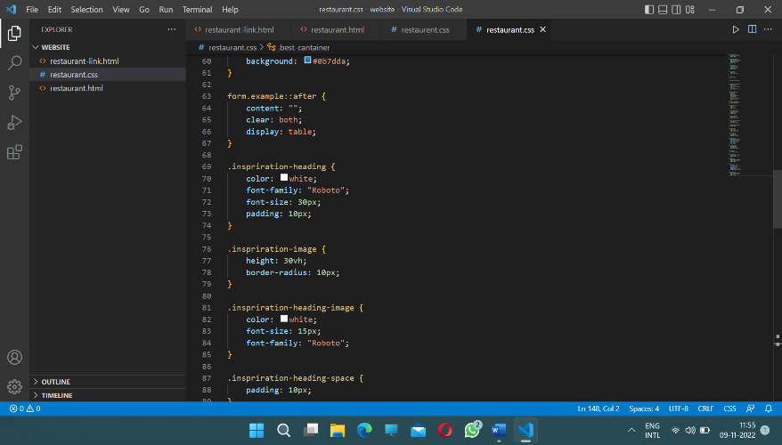

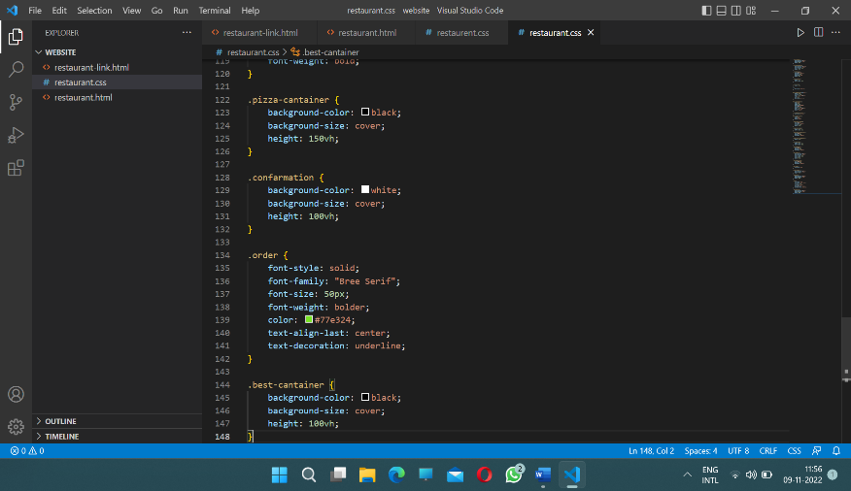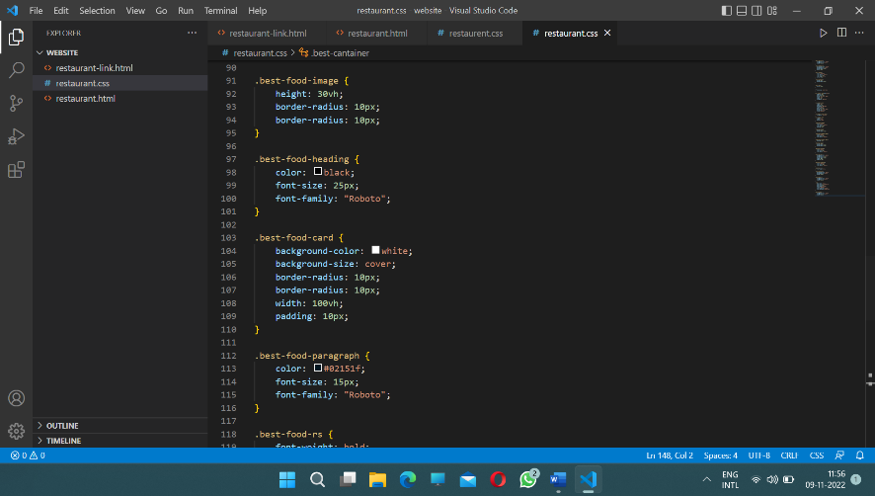

HTML source code:

